Angular Day1

AngularJS Day-1 Definitions (Simple & Clear)

1️ AngularJS
AngularJS is a JavaScript framework developed by Google used to build Single Page Applications (SPAs) using the MVC architecture and two-way data binding.

Single Page Application (SPA)
An SPA is a web application where the page loads once and content updates dynamically without reloading the entire page.

MVC Architecture
MVC stands for:
- Model → Application data
- View → HTML UI
- Controller → Business logic
AngularJS separates these concerns for cleaner code.

ng-app
ng-app is a directive that bootstraps (starts) an AngularJS application and links HTML with AngularJS logic.

AngularJS Module
A module is the root container of an AngularJS application that holds controllers, services, directives, and filters.
angular.module("myApp", []);

Controller
A controller manages application logic and controls the data flow between the view (HTML) and the model.

$scope
$scope is an object that acts as a bridge between the controller and the view, holding data that is displayed in HTML.

Expression ({{ }})
AngularJS expressions are used inside {{ }} to bind and display dynamic data in HTML.

Data Binding
Data binding synchronizes data between the model and the view automatically.

Two-Way Data Binding
In two-way binding, changes in the UI update the model, and changes in the model update the UI automatically.

Ng-model
ng-model binds HTML input elements to $scope variables and enables two-way data binding.

Directive
A directive is a special HTML attribute provided by AngularJS that extends HTML functionality (e.g., ng-app, ng-model, ng-controller).

Quick summary
- Controller → puts data into $scope
- View → reads data from $scope
- ng-model → updates $scope automatically

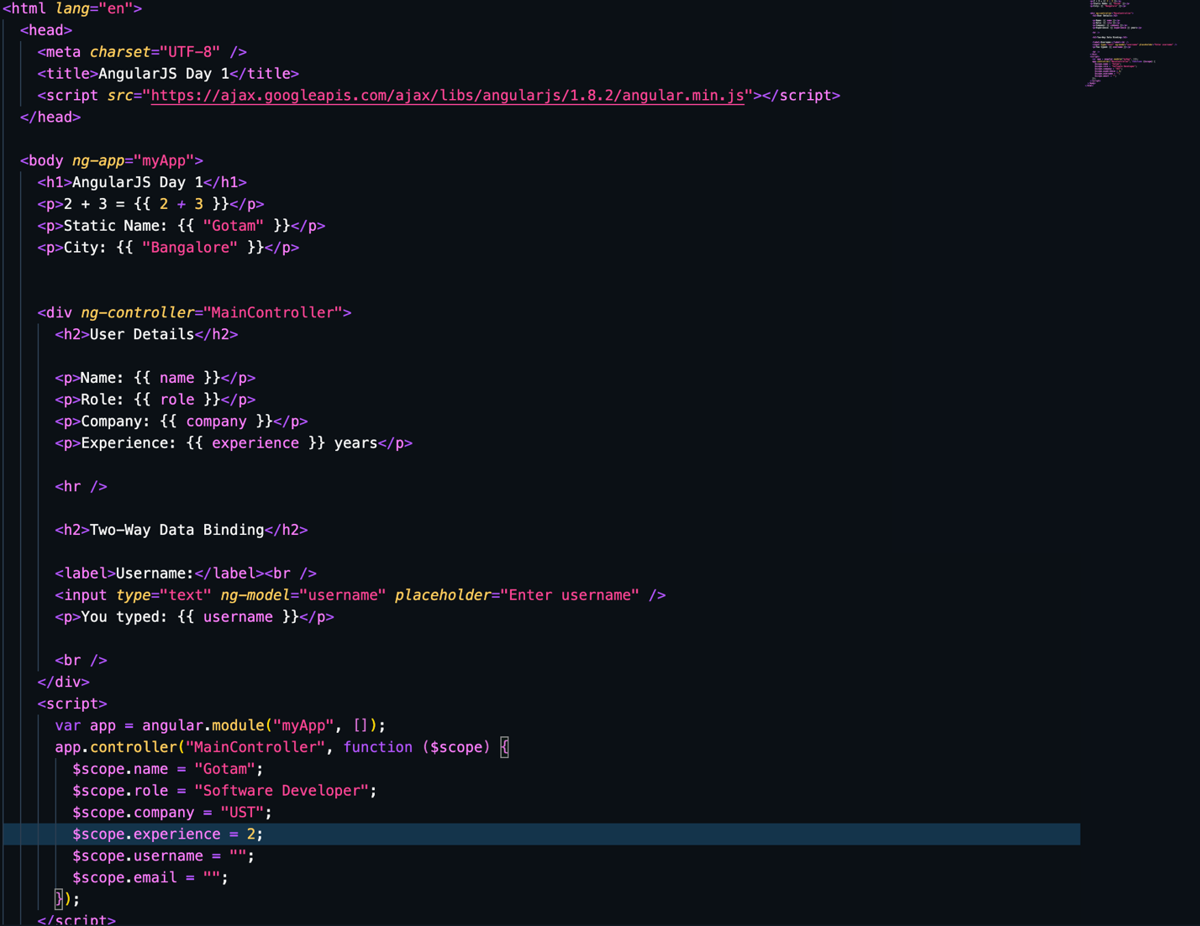

📘 DAY-1 EXERCISES

(Module, Controller, $scope, Binding, ng-model)

Exercise 1: Hello AngularJS
- Create an AngularJS app named myApp
- Display the text: “Welcome to AngularJS”

Exercise 2: Controller & Scope
- Create a controller named UserController
- Declare the following variables:
  - username
  - role
- Display them in HTML

Exercise 3: Two-Way Binding
- Create an input field for username
- Display the typed value in real time below the input

Exercise 4: Multiple Inputs
- Create input fields for:
  - Name
  - Email
  - City
- Display all values in a paragraph

Exercise 5: Simple Calculator
- Take two numbers as input
- Display their addition result using expressions

Exercise 6: Live Text Update
- Create an input field for company
- Display:
Working at company

Exercise 7: Scope Update
- Change a $scope variable inside the controller
- Observe automatic UI updat

Angular Day2

Directive
A directive is a special HTML attribute or element in AngularJS that extends the behavior of HTML.

Key Concepts
- Directives start with ng-
- They connect HTML (View) with AngularJS logic
- They are the core feature of AngularJS

ng-controller
- ng-controller attaches a controller to a specific part of the HTML view.
- <div ng-controller="MainController">

Key Concepts
- Defines controller scope area
- Child elements inherit scope

ng-repeat
ng-repeat is a directive used to iterate over a collection and display data repeatedly.

Key Concepts
- Similar to map() in React
- Automatically updates UI
- Supports objects & arrays
- <li ng-repeat="item in items">
- {{ item }}
- </li>

ng-if
ng-if conditionally adds or removes elements from the DOM.
- <p ng-if="isLoggedIn">Welcome User</p>

Key Concepts
- Element is created/destroyed
- Better for performance when element not needed

ng-show
ng-show conditionally shows or hides elements using CSS.
- <p ng-show="isLoggedIn">Welcome User</p>

ng-if vs ng-show
Feature | ng-if | ng-show
DOM | Removed | Present
Performance | Better | Slower
State | Lost | Preserved

ng-click
- ng-click executes a function when an element is clicked.
<button ng-click="sayHello()">Click</button>
- $scope.sayHello = function() {
- alert("Hello AngularJS");
- };

Key Concepts
- Replaces JavaScript onclick
- Cleaner and testable

DAY-2 EXERCISES

(Directives: ng-repeat, ng-click, ng-show, ng-if)

Exercise 8: Display List
- Create an array languages
- Display it using ng-repeat

Exercise 9: Button Click Event
- Create a button
- On click, display an alert message

Exercise 10: Toggle Visibility
- Create a button
- Show / hide a paragraph using ng-show

Exercise 11: Conditional Message
- If a list is empty
- Display:
No data available
- Use ng-if

Exercise 12: Counter Application
- Initialize a variable count = 0
- Add buttons:
  - Increment
  - Decrement
- Display the count value

Exercise 13: Skill List Manager
- Create an array skills
- Display skills using ng-repeat
- Add a button to hide/show the list
- If the list is empty, show a message

🎯 Practice Instructions
- Write code without copying
- One exercise at a time
- If stuck, ask only about that exercise

